Survey App for ASHA Workers (Aarogya Patrika)

Kartik Manish Chawda

*Dept. of Computer Engineering*

*KJSIEIT, Mumbai, India*

kartik.chawda@somaiya.edu

Nayan Sanjay Bhatia

*Dept. of Computer Engineering*

*KJSIEIT, Mumbai, India*

nayan.bhatia@somaiya.edu

Dharmin Rajesh Chothani

*Dept. of Computer Engineering*

*KJSIEIT, Mumbai, India*

dharmin.chothani@somaiya.edu

Juhi Yogesh Gori

*Dept. of Computer Engineering*

*KJSIEIT, Mumbai, India*

juhi.gori@somaiya.edu

Nisha Vanjari

*Assistant Professor*

*KJSIEIT, Mumbai, India*

nvanjari@somaiya.edu

Yash Chinmay Gandhi

*Dept. of Computer Engineering*

*KJSIEIT, Mumbai, India*

yash.cg@somaiya.edu

***Abstract –* The “Aarogya Patrika” App is a unique solution which digitally links the three government frontline health workers in each village. These are the ANM (a nurse-midwife), the ASHA (community mobiliser) and the Anganwadi worker (overseer of nutrition in pregnant and lactating women, and pre-school children). These three women are responsible for providing health and nutrition services to the last-mile community across villages in India. Though they serve the same population, they don’t team up naturally because of different supervisory systems, databases and work cultures. Further, they are expected to maintain numerous voluminous registers. They can improve effectiveness and efficiency by sharing data and the app enables this in a seamless manner. The App enables the frontline workers to utilize a common database, carry out their routine tasks with ease and maintain integrity of data. It also generates essential government reports, provides an online supervision dashboard and enables referrals. While some technology solutions for frontline workers exist, none bring them together. Through all this, the workers can focus on their primary responsibility of delivering care, aided by data.**

***Keywords –* Asha, Aarogya Patrika, CHW, Anganwadi, healthcare, Vaccines.**

1. INTRODUCTION

ASHA Accredited Social Health Activists workers are helping to build a strong foundation for promoting healthy practices in our society. They play critical role for various health programs of the Government of India. Accredited social health activists (ASHAs) can prevent many of these deaths by helping women and their families recognize maternal and neonatal danger signs and promptly seek care. However, a majority of ASHAs are low-literate village women, and they face significant operational challenges in conducting routine maternal, newborn, and child health (MNCH) activities and in keeping their skills updated. In particular, ASHAs' lack of access to health care information, refresher training, supportive supervision, and user-friendly job aids compromise their ability to contribute to improved maternal and newborn health outcomes. [1]

Basically, ASHAs workers take surveys across different areas and collect information of families and on analysis they provide different Government Yojanas, financial aids and facilities to the eligible families. Currently, the information is

collected on paper and data entry is done manually into excel sheets. This is time consuming and tedious procedure. Also, it becomes difficult to analyze these family’s data and take necessary actions. So, we proposed an app “**Aarogya Patrika**” which digitalizes whole process of data collection and analysis.

Social development of a nation is dependent on the health of its population. The impact of ASHAs on their communities is largely dependent on the quality of their training and other health system factors. Currently there is inadequate health system support for ASHAs including a lack of strong supervision, limited opportunities for continuing education and training and poor workload management. They get limited training on community mobilization, child immunization and others due to which they have limited knowledge and skills. Empowering ASHAs with “Aarogya Patrika” will help them to overcome the barrier

1. LITERATURE SURVEY

**N. D. Valakunde**, describes a system which is used in Uttar Pradesh state to monitor pregnant women in unprivileged parts of the country. The project is expected to reduce the maternal mortality rate by digitizing the work of the health workers by enabling them to monitor the pregnancies of the women in their area with the help of smartphones, effectively and efficiently. The Smart ASHA application is developed in Android Studio framework. The server is deployed on blazer pro using apache-HTTP Server and tables storing the data are implemented in phpMyAdmin-MySQL. [2]

**R. V. Vaidya and D. K. Trivedi**, describes a system which can Track their fitness, Schedule appointments with a Doctor, set a reminder for themselves to take medicines on time and can request blood from a nearby donor in case of emergency and they can inform their relatives about current location. This system is implemented using Android Studio, Firebase, PHP and MySQL. [3]

**Bhatia, Kavita**, describes that by equipping each and every ASHA worker in India with UPASANA, they can provide cheap quality healthcare to the people in rural areas. Upasana is a non-invasive medical diagnostic toolkit designed to be used by ASHA workers so that they can measure the vital parameters of the patients in rural areas and transfer the data to the doctors at the hospital for diagnosis. [4]

1. DESIGN AND IMPLEMENTATION

Since ASHAs faces this problem, so to overcome this problem of Manual Data entry and difficulty of Analyzing the family data the “Aarogya Patrika” is designed with the aim of eliminating all these possibilities of lack of access to healthcare information, refresher training and meaningful supervision so that their ability to contribute to improved maternal and new-born health outcomes will play a major role. The App simplifies public administration, eliminating the need of data-entry operators. Basically, app manages to convert the data into digital format right from the point of entry, to be used, analyzed, accessed and processed across the health system by all relevant staff members. CHW (Community Health Workers) manages admin panel where they analyze the health data of families.

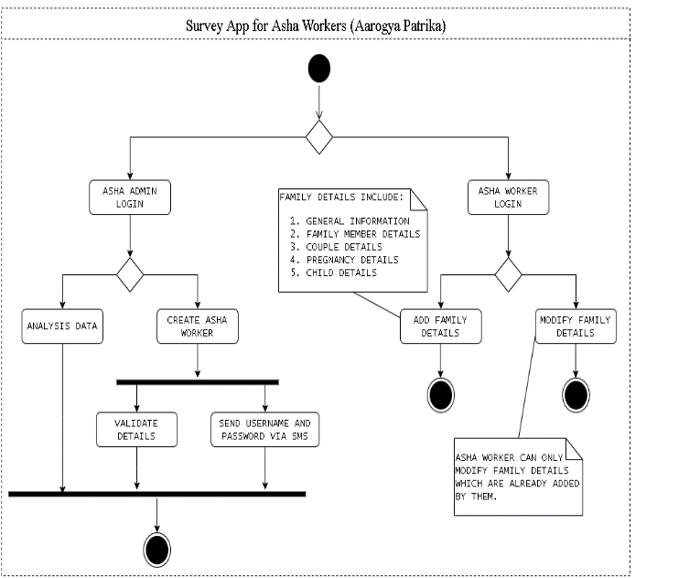All the ASHA Workers are provided with an Android Application through which they can enter data without any hassle. The data is stored in real time database which can be accessed any time. A dashboard is provided for the CHW who is Admin of ASHA Workers. The dashboard contains statistical analysis of the data. Also, data analysis can be done based on different aspects of data. This also allows the real-time monitoring of frontline workers by their supervisors. This also empowers the women in rural areas with technology.

1. CONCLUSION
2. REFERENCES